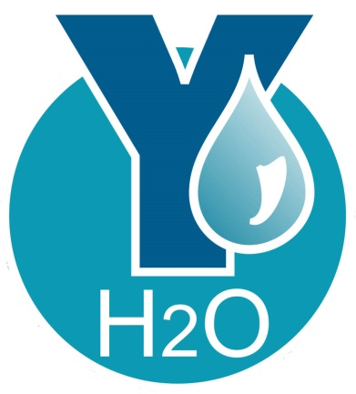

Baltimore City

2018 Youth Water Mentoring Program

Application

YH2O - Baltimore City’s Youth Water Mentoring Program is a public-private partnership between – the Mayor’s Office of Employment Development (MOED), the Department of Public Works (DPW) – and the Chesapeake Water Environment Association. The dual goals of the program are to:

- educate local teens and young adults about the water industry and its careers opportunities

- develop a pipeline of future workers with the knowledge, skills and abilities needed to fill entry-level positions in the water industry

At the completion of the program, participants will be well qualified to apply for entry-level positions with Public and Private sector water industry employers.

Please verify the following information. Are you:

A resident of Baltimore City.
________Yes _______No

Between the ages of 18 and 24.
________Yes _______No

Out of work and not enrolled in post-secondary education.
________Yes _______No

A high school or GED graduate.
________Yes _______No

Are you interested in learning more about careers in the water industry?
________Yes _______No _______Not sure

Are you enrolled or ever been enrolled in one of the Youth Opportunity Centers (YO! Baltimore).
________Yes _______No _______Not sure

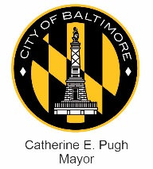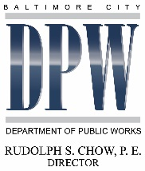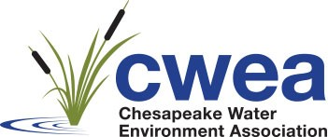

GENERAL INFORMATION

Legal Last Name: __________________________First Name: _______________ M: __________________

SSN: _____ -____-_______ Age: _____DOB: _____/_____/_____ Gender: _______________________

Current Address: _____________________________________________________________________________
Mailing Address (if different):_________________________________________________________________

Telephone: Home: Cell: ___________ Work: ______________________________

In case of an emergency, contact:
Contact information: Phone: ______________________ Cell: _____________________________________

Address: ___________________________________________________________________________________

Relationship: _______________________________________________________________________________

Referral

How did you hear about YH2O Youth Water Mentoring Program? ___________________________________

If you were referred to the program, who referred you?

Name ______________________________________________________________________________________

Agency ____________________________________________________________________________________

Relationship __________________________ (for example: case manager, sponsor, Water Program Alumni, friend)

Citizenship

Are you a United States citizen? ____Yes ____No

If no, are you legally entitled to work in the United States? _____Yes _____No

Do you live in Baltimore City? _____ Yes _____No

PERSONAL HISTORY

Educational History
Please list the schools attended. Start with high school and include any vocational and/or any post-secondary schools.

School | Dates | Diploma/certificate/course of study

Employment History
Occupation/Trade _______________________ School/Training: ___________________________

Please list your work experience for the past five years in the following charts. Start with your most recent job held. If you were self-employed, give the name of your business.

Name of Employer: | Supervisor’s Name | Employment dates | Pay or salary
City, State, Zip | Phone Number | From:  To: | Start:  Final:
Your last job title:

Reason for leaving (be specific)

List the jobs you held, duties performed, skills used and learned, advancements or promotions while you worked at this company

Name of Employer: | Supervisor’s Name | Employment dates | Pay or salary
City, State, Zip | Phone Number | From:  To: | Start:  Final:
Your last job title:

Reason for leaving (be specific)

List the jobs you held, duties performed, skills used and learned, advancements or promotions while you worked at this company

Name of Employer: | Supervisor’s Name | Employment dates | Pay or salary
City, State, Zip | Phone Number | From:  To: | Start:  Final:
Your last job title:

Reason for leaving (be specific)

List the jobs you held, duties performed, skills used and learned, advancements or promotions while you worked at this company

STENGTHS ASSESSMENTS
Please use complete sentences when answering these questions.

How do you deal with stressful situations? What is your strategy to calm down if you get into an argument with a coworker/friend, etc.? What if you cannot just “walk away?”
______________________________________________________________________________________________
______________________________________________________________________________________________
______________________________________________________________________________________________
______________________________________________________________________________________________
_______________________________________________________________________________________________

List three things you see as your personal strengths and how they help you succeed in life. _____________________________________________________________________________________________

_____________________________________________________________________________________________

_____________________________________________________________________________________________

List three skills you would bring to the Youth Career Mentoring program.
_____________________________________________________________________________________________

_____________________________________________________________________________________________

_____________________________________________________________________________________________

GOALS/EXPECTATIONS
Please use complete sentences when answering these questions.

Why are you applying to this program?

_________________________________________________________________________________________________
_________________________________________________________________________________________________
_________________________________________________________________________________________________

What are your career goals? ____________________________________________________________________
_________________________________________________________________________________________________

________________________________________________________________________________________

________________________________________________________________________________________

________________________________________________________________________________________
Program Requirements
Listed below are some of the YH2O Youth Water Mentoring program requirements: Please initial next to each one to indicate your agreement and acceptance.

- I understand that program activities will include job-readiness sessions, water industry career exploration, worksite tours, job shadowing, guest speaker lectures, etc., and that my regular attendance is required. _______

- I understand that I must be on time and prepared to stay for program activities from start to finish ______

- I understand that I must be willing to accept feedback from my instructors and mentors, and maintain a respectful, positive attitude. _______

- I understand that I am responsible for my overall success in the program. _____

- I understand that the Mayor’s Office of Employment Development (MOED), Department of Public Works (DPW) and/or Chesapeake Water Environment Association (CWEA) are not responsible for damage, loss, and/or theft of my personal property. _______

- I understand that I am required to take part in a safety training workshop. _________

- I understand that I will be connected with a career coach/mentor who is a water industry professional from DPW or CWEA, and that I must talk with them at least twice per month (in person, or by phone, email, and/or text). _________ (MANDATORY)

- I understand that I must register for the 2018 YouthWorks summer jobs program. _________

- I understand that it is my responsibility to inform the program coordinator, Mr. Anthony Greene, if I require additional assistance or if I am no longer able to participate in the program. _________

- I grant permission for the Mayor’s Office of Employment Development to use my image, quotes, and/or voice in any and all forms of electronic or print for purposes that promote MOED, The YH2O Program, YouthWorks, and/or the City of Baltimore. _________

Applicant’s signature: __________________________________ Date: _____/____/_____

APPLICANTS DO NOT WRITE BELOW THIS LINE

Application reviewed by:

Name: ______________________________________________

Title: ________________________________________________

Reviewer’s signature: __________________________________ Date: _____/____/_____

Application updated 1/9/2018

